Overview:

* Throw in accuracy: 87.1% | Opponent throw in accuracy: 90.9%
* Best overall passing accuracy this season 80.9%
* **Finally hit 72% forward passing accuracy goal**
* Are passes when attacking the right flank tended to be backward
* Carter and Jonah's percentage of passes that were forward were both below 45%
* The left side was 11% more accurate passing into the attacking third than the right side.
* **Best defensive duels accuracy this year (73.7%) by a significant margin (closest is 69.8%)**
* Jonah, Adam, and James won a lot of defensive duels (>80%)
* We minimized defensive duels close to the corners and top of the box.
* **Offensive duels accuracy was extremely low at 27%**
* Offensive duels was the worst win rate this season
* We also did not have a ton of offensive duels and taking players on which was also the least amount of offensive duels this season
* Kai lost all 13 of his offensive duels
* Max increased his offensive duels win rate by a lot compared to previous games
* Midfield won a majority of their offensive duels
* 60% of CSUN’s shots were outside of the box
* 12/15 of CSUN’s shots were below .1 xG the other three were only .21, .21, and .24
* **Majority of CSUN’s chance origins were in our attacking half**
* Only 1 of the 13 shots that wasn’t a free kick was off of a counter attack most of CSUN’s opportunities consisted of 7+ passes

Passing

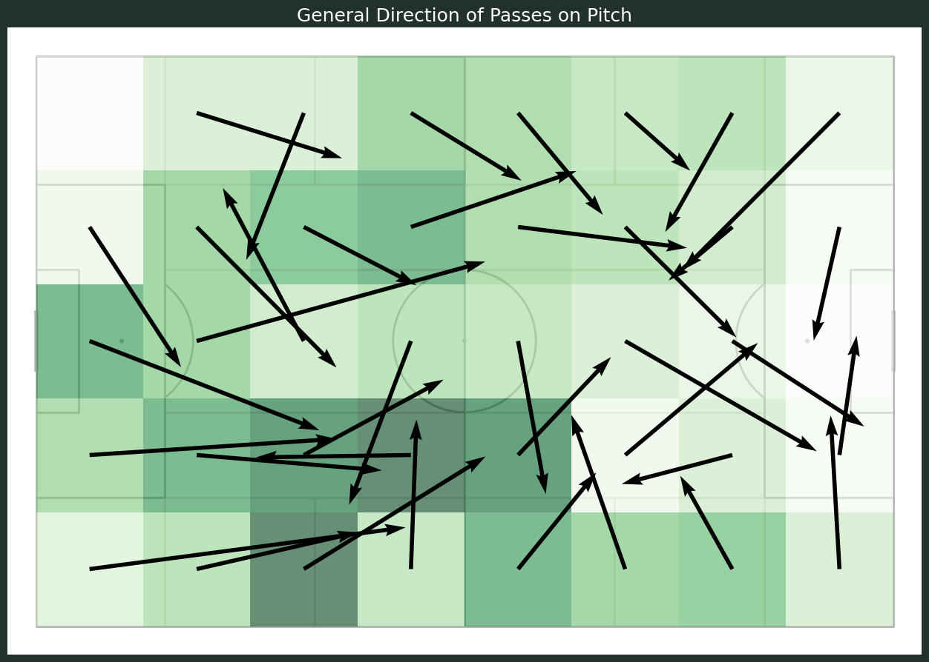

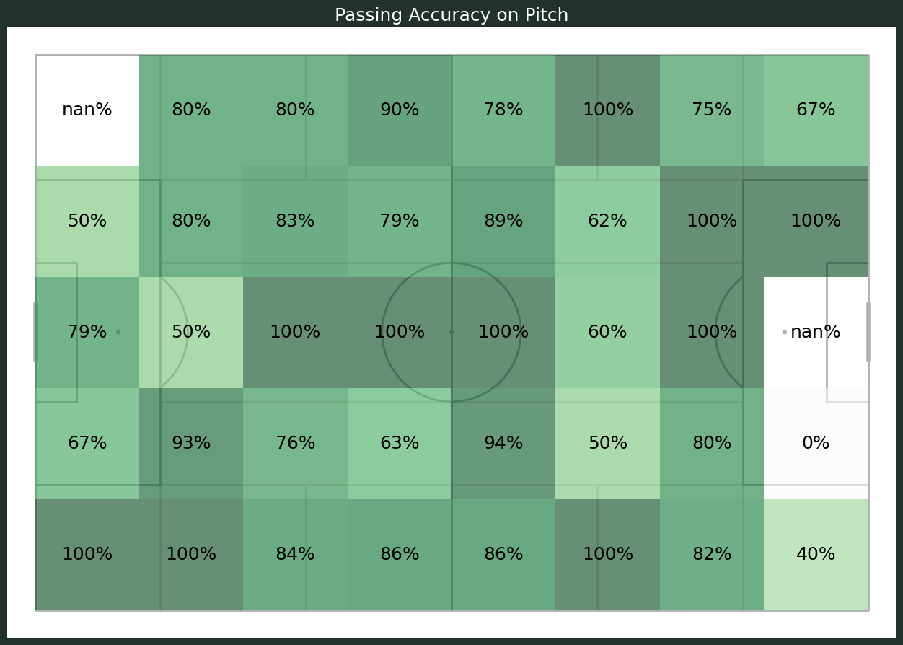

* 60.7% of forward passes were on the right side while only 30.6% were on the left side | different from previous games where majority was on the left side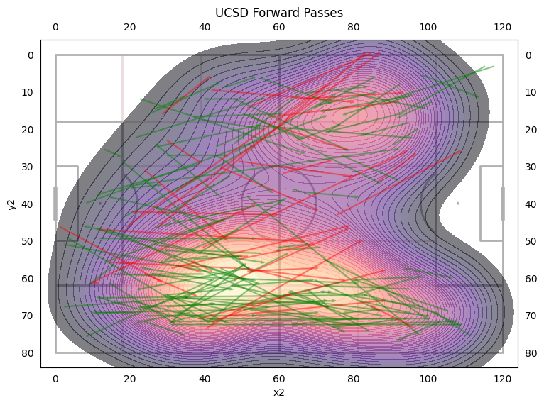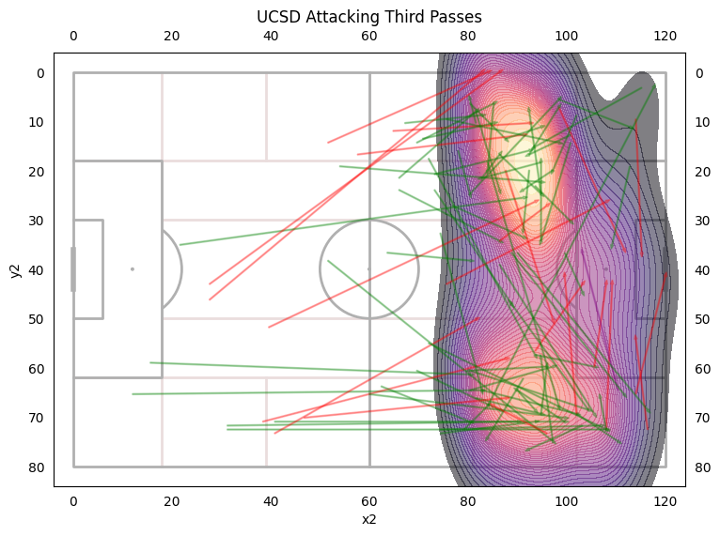
* 45.8% of successful passes into the attacking third were on the left and 38.8% of successful passes into the attacking third were on the right side
* The left side was 11% more accurate passing into the attacking third than the right side.

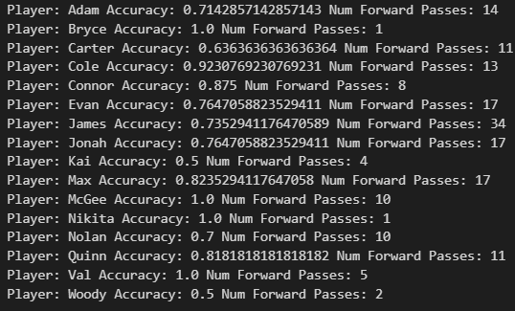

* Almost everyone’s passing accuracy is above 75% even our attacking players passing accuracy was high
* Carter and Jonah's percentage of passes that were forward were both below 45%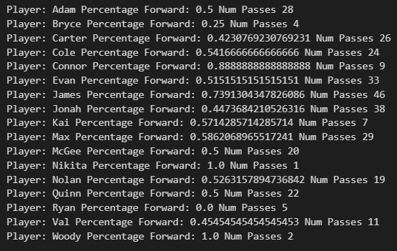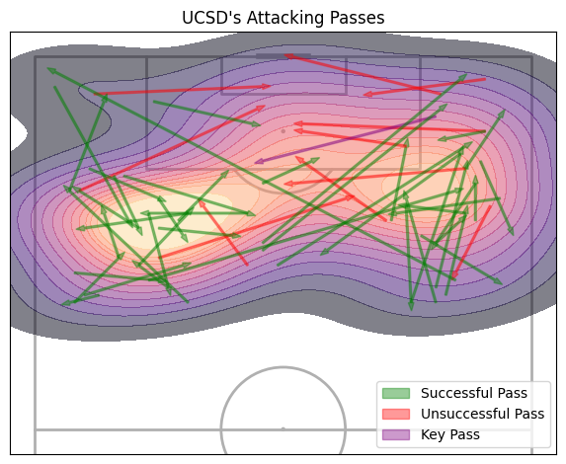

Defensive duels

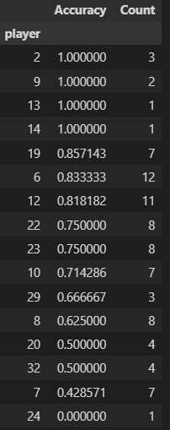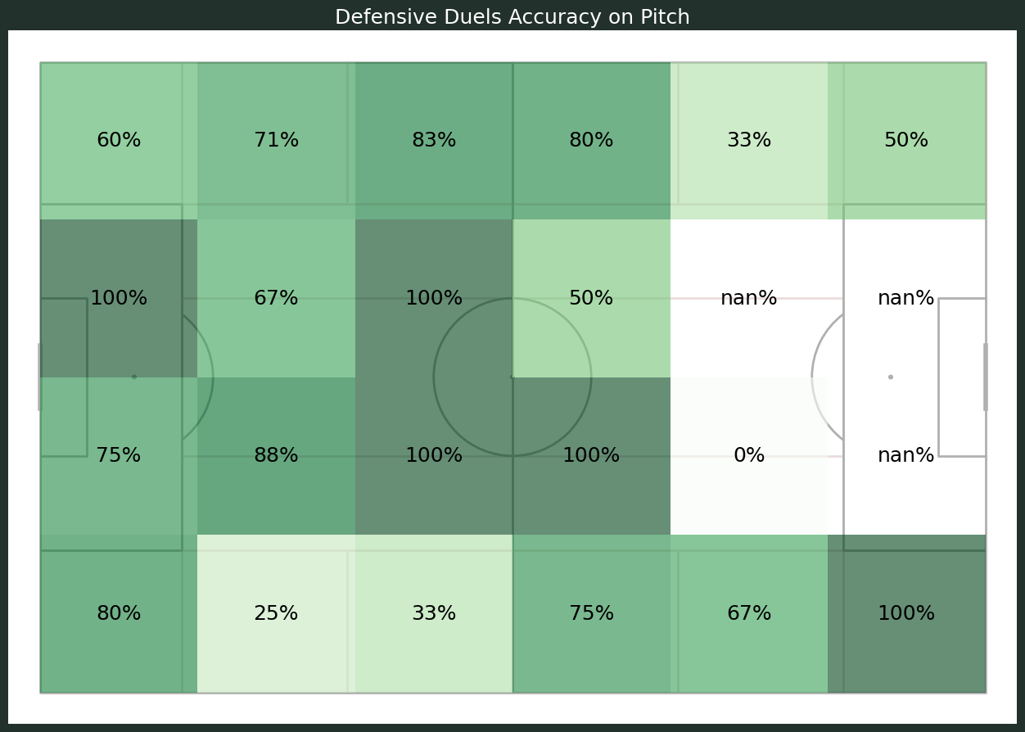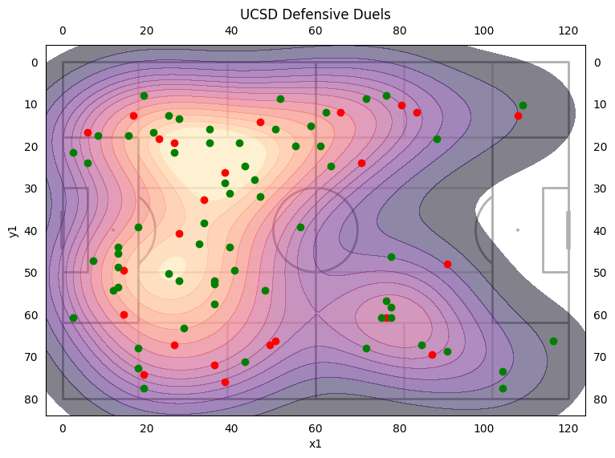

* We minimized defensive duels close to the corners and top of the box.
* We won 73% of our defensive duels which is the best this season.
* Adam, James, and Jonah won a lot of defensive duels
* Adam’s highest defensive duels accuracy this year.
* One of Jonah’s highest defensive duels accuracies this year

Offensive duels

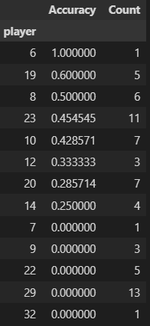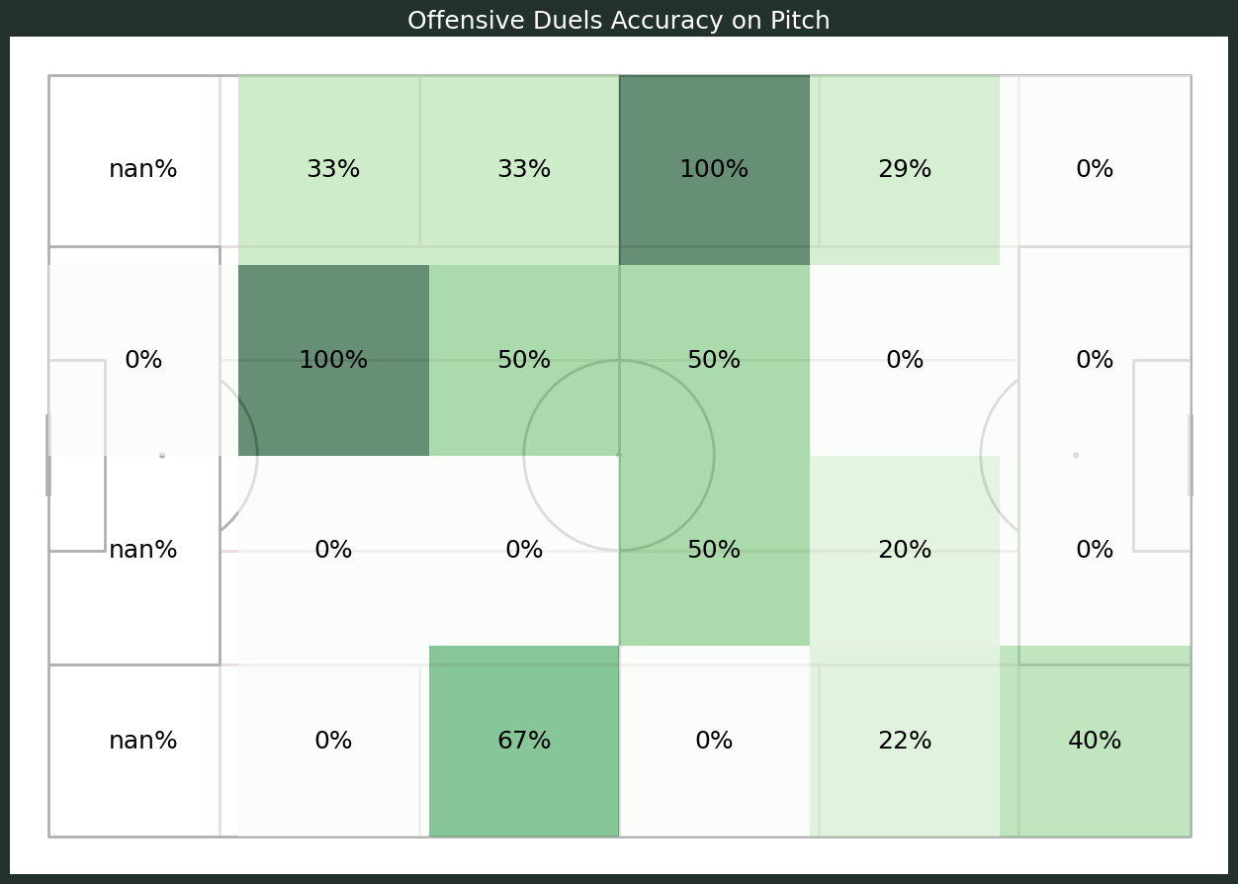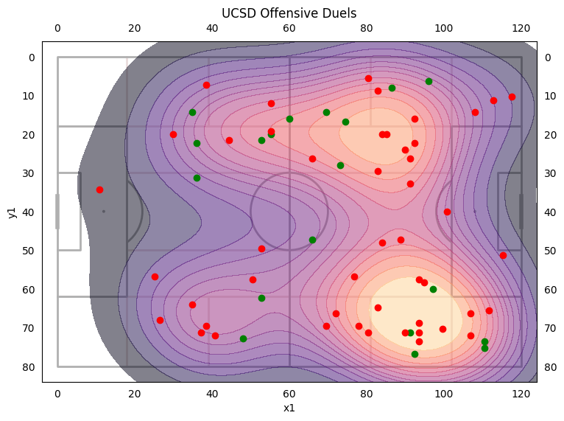

* Offensive duels accuracy was extremely low at 27%
* Offensive duels was the worst win rate this season
* We also did not have a ton of offensive duels and taking players on which was also the least amount of offensive duels this season
* Kai lost all 13 of his offensive duels
* Max increased his offensive duels win rate by a lot compared to previous games
* Midfield won a majority of their offensive duels

Opponent’s Chances

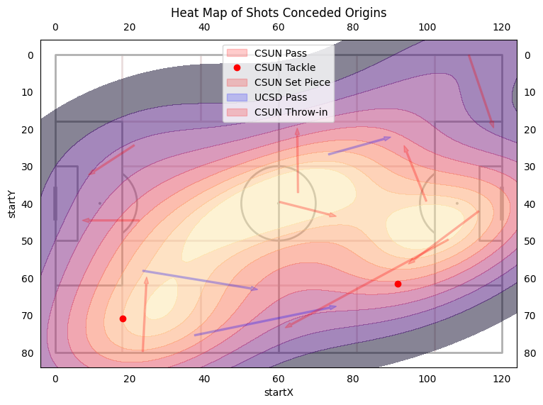

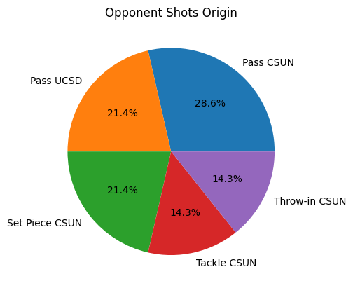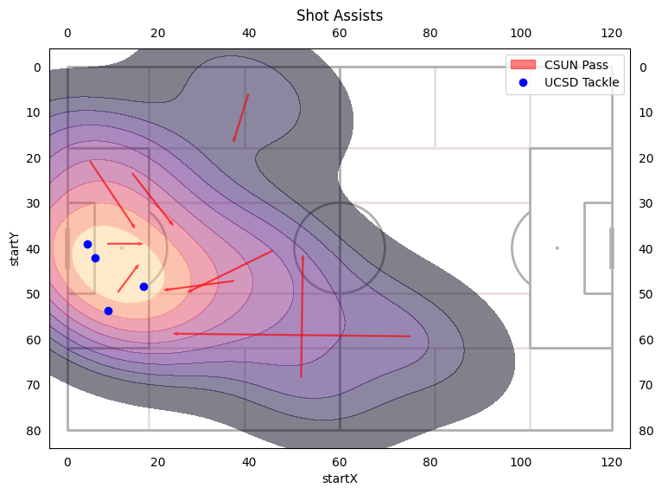

* 60% of their shots were outside of the box
* 12/15 shots were below .1 xG the other three were only .21, .21, and .24
* Majority of the origins were in our attacking half
* Only 1 of the 13 shots that wasn’t a free kick was off of a counter attack most of CSUN’s opportunities consisted of 7+ passes